A method for generating a wavepulse is to move one end of a spring quickly up a distance d and then back down (see figure). The hand takes the same amount of time to move up as to move down. Consider a second wavepulse generated with the same amplitude, d, on a different spring (spring 2). It is observed that the wave speed on spring 2 is half that in the original spring (spring 1).

How can you account for the difference in speed of the wavepulse on the two springs? Explain.

What could you change about the creation of the second wavepulse or spring 2 so that the wavepulse on spring 2 traveled at the same speed as the wavepulse on spring 1? Explain.

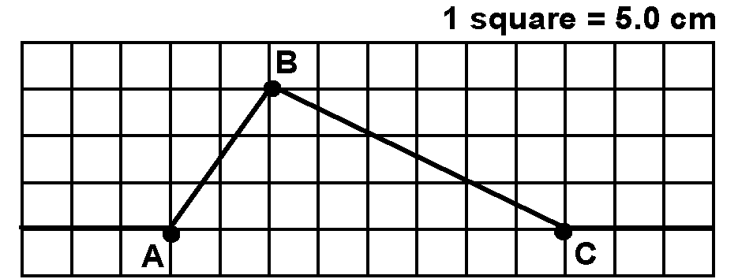The pulse shown in the figure at the right is moving to the right at 50 cm/s.

Draw velocity vectors to indicate the directions of the instantaneous velocity of the piece of spring located at the horizontal midpoint of each square.

Using qualitative reasoning explain how the velocity of a piece of spring is related to the slope of that piece of spring.

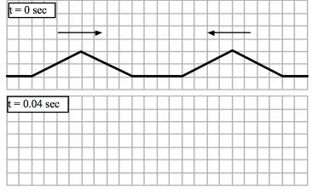
The diagram at the right shows two wavepulses moving toward each other on the same side of a spring at time t = 0 sec. Each pulse is moving at a speed 100 cm/sec. Each block represents 1 cm. In the grids provided to the right, sketch the shape of the spring (with a solid line) at 0.04 sec.

