1. In tutorial, you compared the relative brightness of the bulbs in the three circuits shown. In the diagrams, boxes have been drawn around the networks of bulbs in each circuit.

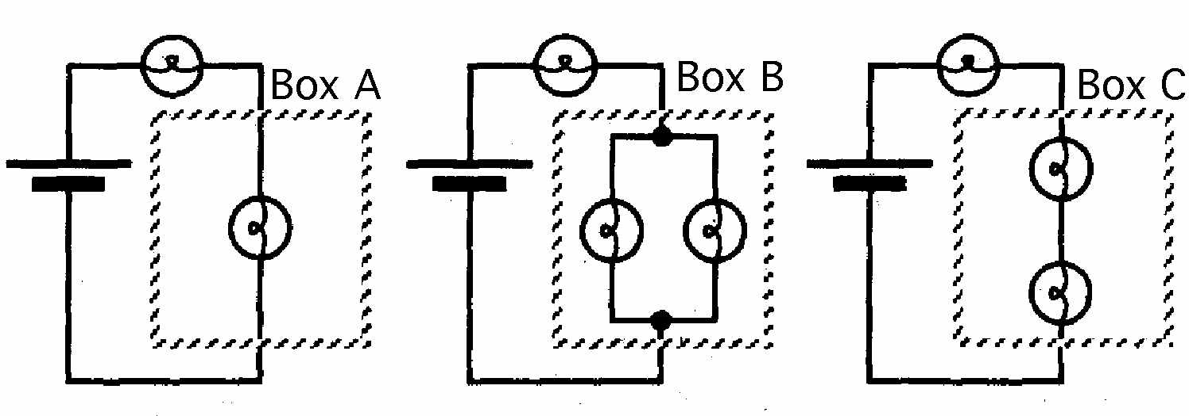

On the basis of your observations and the rule you developed at the end of the tutorial relating current through the battery to total resistance, rank the networks (boxes) A-C according to their equivalent resistance. Explain your reasoning on the basis of the model. (Do not use math.)

2. Use the rule for electric current to rank the networks shown below in order according to resistance. Explain your reasoning.

