Electrophorus
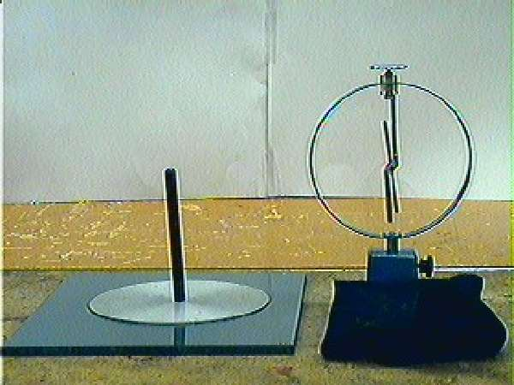
In the early days of electrical investigations (about the time of the American revolution), it was difficult to accumulate significant quantities of unbalanced electric charges for experiments. A device to produce an unbalanced charge relatively consistently was the electrophorus (invented by Volta). A device to measure fairly small amounts of unbalanced charge was the electroscope (invented by Nollet). Modern versions of these are shown in the picture at the right.
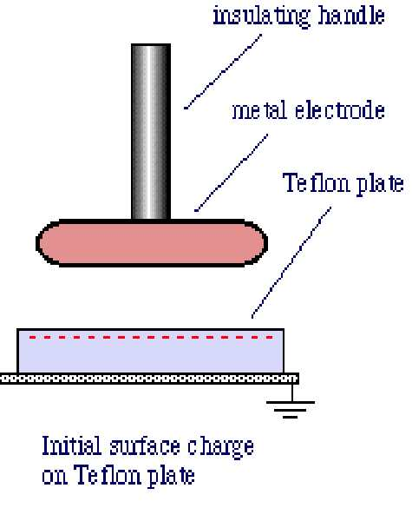
The electrophorus consists of a plate of insulating material (Teflon or Lucite – originally it was of wax), and a metal disk attached to an insulating rod. When the Teflon is rubbed by a flannel cloth it becomes charged. (You can tell by bringing the back of your arm up near it and feeling the little hairs move.) The metal disk, held by the insulating rod, is placed on the plastic plate and a finger lightly touched to the back. The finger is then removed and the disk lifted away from the plate. The metal disk now has a charge which can be easily transferred to other conducting objects by touching.
On a dry day (!), the charge on the plastic plate will remain on the plate for a very long time. The process of charging the metal disk can be repeated many times without “using up” the charge on the plastic plate.
Explain clearly how the electrophorus works, being careful to include in your explanation a clear description of why the charge on the plate is not used up in the process of charging the metal disk.

Electroscope
In the figure below are shown schematics of two versions of an electroscope: a historic version on the left with gold foil leaves, and a more modern one with a pivoting metal arm on the right. (The more modern version is shown in the photograph on the previous page.)

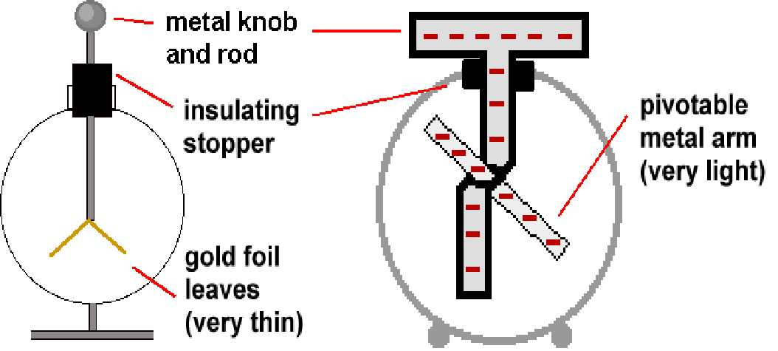

The charged metal disk of an electrophorus is touched to the metal knob of the electroscope and removed. The movable leaves of the electroscope, which hung straight down when the electroscope was uncharged, now stand apart as shown in the two figures above. Explain why this happens, tell what sign of charge you think the electroscope has, and why you think so.

The electroscope is neutralized by touching the knob. Now the charged metal disk of the electrophorus is brought near to the knob but doesn’t touch it. The leaves separate. Explain why.

While the disk of the electrophorus is near to the electroscope’s knob (but not touching) the knob of the electroscope is touched with a finger and then the electrophorus disk is taken away. The leaves stand out again. Explain why this happens, tell what sign of charge you think the electroscope has, and why you think so.

Balloon
Rub a balloon on your head and stick it to the wall. And it sticks—very nice. This question is about why, after a while, it falls off. Consider each of the following explanations.

- It falls because it uses up the energy you put on it when you rubbed it.
- It falls because it uses up the charge you put on it when you rubbed it.
- It falls because the energy you put on it slowly leaks off into the wall or the air.
- It falls because the charge you put on it slowly leaks off into the wall or the air.

Which explanation fits best with the model we’ve discussed?

Given your choice for part a, would it be possible, in principle under ideal circumstances, for a balloon to stick to a wall indefinitely?

