1. A small bulb is placed in front of a convex lens.
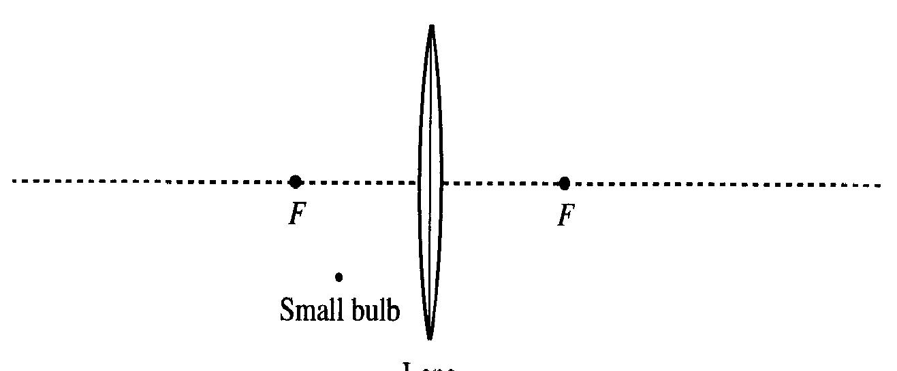

a. Suppose that the bulb is placed as shown. Draw an accurate ray diagram to determine the location of the image. Label the image location.

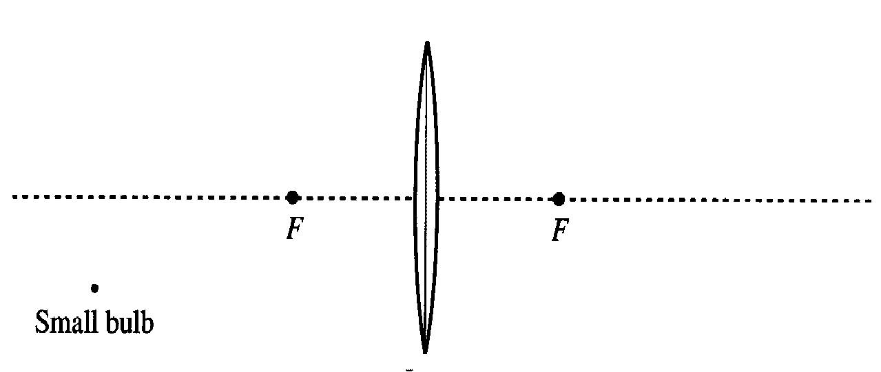
b. Repeat part a for the case shown at right, in which the bulb is farther from the lens.

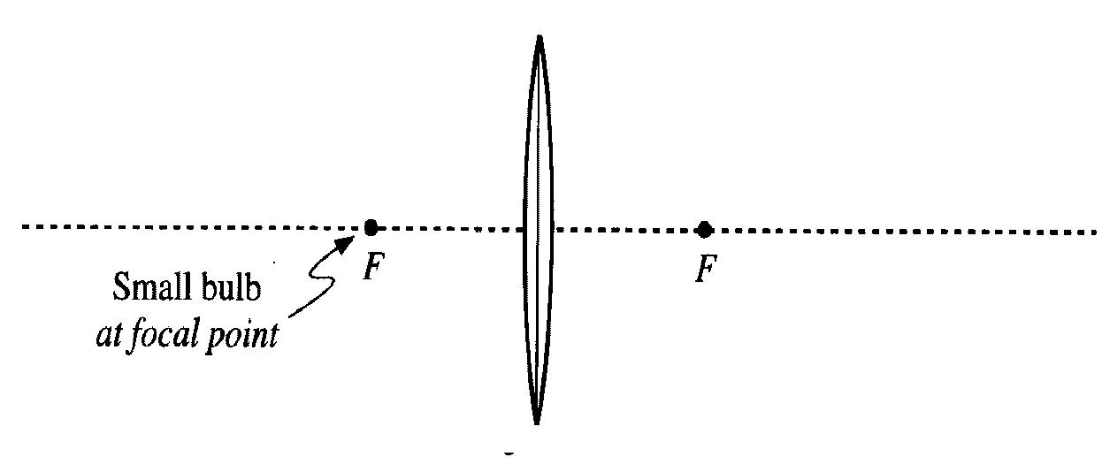
c. Suppose that in each case above you were to place a small paper screen at the image location.
What you would see on the screen in each case? Imagine that the room is dark except for the small bulb.

d. The light bulb is placed at one focal point of the lens as shown at right.

Draw at least five rays from the bulb that pass through the lens.

Where is the image located in this case? Explain. (Hint: How are the rays that have passed through the lens oriented? From where do these rays appear to have come?)

