When are things at the same temperature?

Two hours before this lecture, a cup of boiling water and a cup of cold water from the refrigerator were brought into this room.

Would you expect them now to be at the same temperature or at different temperatures? Why?

Would you expect the (formerly) boiling water to have a temperature greater than, less than, or equal to the temperature of the air in this room? Why?

 Class discussion. POLLING (1 = same, 2 = different). Experiment.

Consider an empty chair in this room. Which part of it do you think is at a colder temperature: The metal or the plastic? Why?

 POLLING (1 = same, 2 = different). Experiment. Class discussion.

After looking over your above answers, come up with one or two questions or issues that you think this ILD should address next. Explain why you think those issues are important for your understanding.

 Class discussion.

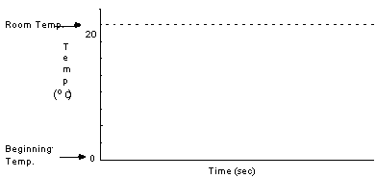
Comparing rates of heat flow.

A metal object at room temperature (20° C) is about to be dunked in ice water (0° C). After it’s dunked, we’ll continually measure the metal’s temperature. (Note: The “beginning temperature” is 20° C, not 0° C.)

Using a dashed line, sketch your prediction for the resulting temperature vs. time graph.

 Experiment. Class discussion.

Sketch the experimental result using a solid line.

Now we’ll repeat the dunking experiment, but with a plastic rather than a metal object.

Using a dashed line, sketch your prediction for the resulting temperature vs. time graph. Emphasize in what ways the graph is similar to, and different from, the “metal” graph above.

 Experiment. Class discussion.

Sketch the experimental result using a solid line.

Based on what you’ve seen, which material allows heat to flow into and out of it more quickly: metal or plastic. Why.

 Class discussion.

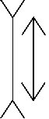
It’s time to reconcile. Explain why the metal part of the chair feels colder than the plastic part, even though they’re at the same temperature.

In terms of helping you understand physics you actually need to know, what was the point of parts A and B above? Why did we do those experiments?

